Admin

|  |  |  |
| --- | --- | --- |
| **Input** | **Expected Output** | **Output** |
| Username: Admin  Password: 1234 | Home Page | Home Page |
| Username: Admine  Password: 1234 | Incorrect Username  or Password Error | Incorrect Username  or Password Error |
| Username: Admin  Password: 12345 | Incorrect Username  or Password Error | Incorrect Username  or Password Error |
| Username: Admine  Password: 12345 | Incorrect Username  or Password Error | Incorrect Username  or Password Error |

Student

|  |  |  |
| --- | --- | --- |
| **Input** | **Expected** | **Output** |
| Username: Erin  Password: soen341 | Home Page | Home Page |
| Username: Erine  Password: soen341 | Incorrect Username  or Password Error | Incorrect Username  or Password Error |
| Username: Erin  Password: soen341 | Incorrect Username  or Password Error | Incorrect Username  or Password Error |
| Username: Erine  Password: soen341 | Incorrect Username  or Password Error | Incorrect Username  or Password Error |

**Usecase 1 – Logging In**

To log in, head to the ‘Login’ tab from the main screen as outlined below and fill out the user information. Finally, press the ‘Login’ button at the bottom, and if you wish for the browser to remember the identification, select the “Remember me next time” checkbox.

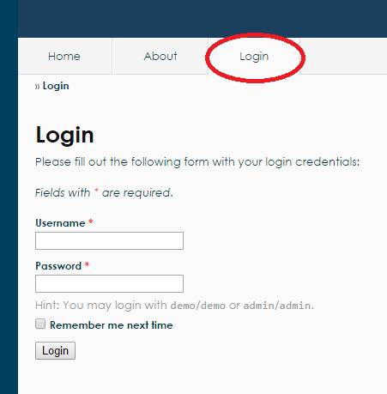

**Usecase 2 – Logging Out**

To log out, simply press the ‘Logout’ button as outlined below, and you will be redirected to the main page.

